THE CORPORATION OF THE MUNICIPALITY OF FRENCH RIVER

BY-LAW 2025-XX

BEING A BY-LAW TO REGULATE, CONTROL AND ALLOW FOR THE KEEPING OF BACKYARD HENS IN THE MUNICIPALITY OF FRENCH RIVER

WHEREAS sections 8, 9 and 10 of the Municipal Act, 2001, as amended, authorize a municipality to pass by-laws necessary or desirable for municipal purposes, and in particular paragraphs 5, 8 and 9 of subsection 10(2) authorize by-laws respecting: the economic, social and environmental well-being of the municipality; the protection of persons and property; and animals;

AND WHEREAS section 103 of the Municipal Act, 2001, as amended, provides that where a municipality has passed a by-law to regulate or prohibit with respect to the being at large or trespassing of animals, the municipality may provide for the seizure, impounding and sale of seized and impounded animals;

AND WHEREAS Section 128 of the Municipal Act, 2001, S.O. c.25, as amended provides that a municipality is authorized to pass a by-law to prohibit and regulate public nuisances;

AND WHEREAS Section 129 of the Municipal Act, 2001, S.O. c.25, as amended provides that a municipality is authorized to pass a by-law to prohibit and regulate noise, vibration, odour, dust and outdoor illumination;

AND WHEREAS section 391 of the Municipal Act, 2001, as amended, provides that a municipality may pass bylaws imposing fees or charges for services or activities provided or done by or on behalf of the municipality;
AND WHEREAS section 425 of the Municipal Act, 2001, as amended, provides that a municipality may pass by-laws providing that a person who contravenes a by-law of the municipality passed under the Municipal Act, 2001 is guilty of an offence;

AND WHEREAS Section 429 of the Municipal Act 2001, S.O., as amended provides that a municipality may designate an offence as a continuing offence and provide for a minimum and maximum fine for each day or part of a day that the offence continues;

AND WHEREAS it is considered desirable to pass a by-law relating to the keeping of Backyard Hens within the Municipality of French River.

NOW THEREFORE the Council of the Municipality of French River enacts as follows:

SHORT TITLE:

The short title of this By-Law shall be the “Backyard Hen By-Law”.

DEFINITIONS

- “Approved Manure Container” means an area used for the temporary storage of manure that can be conveniently accessed for the removal of manure from the property that does not exceed 0.5 m on its longest dimension and does not exceed 1 m in height (example a 45 Gallon drum). This container shall be setback an appropriate distance from any property line, well cap or the shoreline of a body of water so as not to create a nuisance.

- “At Large” means any hen outside of a hen coop or found in any place other than the premises of the owner of the hen within approved setbacks.

- “Advertise” means to have a sign, billboard, poster or other such thing posted in a visible location on or in relation to a property or posted online by a resident of the property, expressing the sale of a product or service.

- “Control” includes care and custody.

- “Council” means the appointed Council for the Municipality of French River.

- “Dispatch” means to destroy, euthanize, or otherwise cause the death of a hen.

- “Dwelling Unit” means one or more rooms connected together as a self-contained, separate unit in the same building comprising all or part of the building and constituting an independent housekeeping unit for residential occupancy by persons with facilities for persons to sleep, cook, and eat and including its own sanitary facilities.

- “Hen” means a domesticated female chicken (Gallus gallus domesticus) that is at least four (4) months old and is kept for the purpose of egg laying. For the purposes of this by-law and the Noise By-Law as amended, and Responsible Animal Ownership By-law as amended and Municipal Zoning By-law as amended, a hen shall not be considered livestock.

- “Hen Coop” means a structure which is completely enclosed and constructed in accordance with this By-Law, is built with sufficient materials and maintained in good repair so as to prevent any hens being kept from leaving the hen coop and is constructed to allow access to an enclosed area outdoors that is attached to the hen coop and deemed to be part of it.

- “Keep” means to have temporary or permanent control or possession of a hen and the words “kept”, or “keeping” have a similar meaning.

- “Municipal Law Enforcement Officer (MLEO)” means any person appointed by the Corporation of The Municipality of French River to enforce the provisions of this By-Law.

- “Municipality” means the Corporation of the Municipality of French River.

- “Person” means any individual or corporation that possesses or keeps a hen or any individual or corporation that owns any property where a hen resides and permits or allows hens or poultry to reside on that property.

- “Poultry” means any single bird or flock of any domesticated avian species that is kept by a person for any purpose and shall not include any hen as defined.

- “Premises” means the entire lot on which a single dwelling unit building, or a multi-dwelling unit building is situated and includes a vacant lot.

- “Rear Yard” mean a yard extending across the full width of a lot between the rear lot line and the
nearest wall of any principal building or structure on the lot. On Waterfront Residential properties, the
rear yard is the full width of the lot between the highwater mark and the nearest wall of any principal building or structure on the lot.

- “Rooster” means a male chicken (gallus gallus domesticus).

- “Rural Property” means any property zoned ‘Rural’ under the Municipal Zoning By-Law as amended.

- “Waterfront Property” means any property zoned as ‘Waterfront Residential” under the Zoning By-Law as amended.

- “Town Limits” means the areas defined within Schedule ‘B’ of this By-Law and shall include any property with frontage on a road indicated in Schedule ‘B’.

GENERAL PROVISIONS

  - This By-law shall apply to all parcels of land within the geographic limits of the Municipality of French River zoned Residential One (R1), Residential Two (R2), Waterfront Residential (WR), and Rural Residential (RR) in the Municipality’s Zoning By-law as amended.

  - No provision of this By-Law shall be used to limit or regulate any Rural property as it relates to the keeping of hens or poultry.

  - No Person shall keep or permit the keeping of any hens on a rental property without written permission from the property owner.

  - No person shall fail to remove hens from a rental property if such permission described in Section 3.3 is removed by the property owner.

  - No Person shall keep or permit the keeping of more than five (5) hens on a property located within the town limits as described in Schedule B.

  - No Person shall keep or permit the keeping of more than ten (10) hens on any property outside of the town limits as described in Schedule B.

  - Regardless of Section 3.6, no Person shall keep or permit the keeping of more than thirty (30) hens outside of the town limits as described in Schedule B on properties that are equal to or larger than 5 acres in size.

  - No Person shall keep or permit the keeping of a rooster.

  - No Person shall allow or permit a hen to run at large.

  - No Person shall allow or permit a hen to defecate outside of a hen coop or enclosed outdoor area within approved setbacks.

  - No Person shall fail to or allow the failure of the removal of manure from an approved manure container if negative conditions arise from the storage of manure including excessive odour.

  - No Person shall sell or permit the sale of any eggs, manure, meat or other products derived from hens.

  - No Person shall advertise or permit the advertising of the sale of, eggs, manure, meat or other products derived from hens.

  - No Person shall dispatch or permit the dispatching of a hen within town limits.

  - No person shall keep or permit the keeping of hens on any part of a property other than a rear yard.

- PROVISIONS OF CARE AND WASTE DISPOSAL

  - Every person who keeps a hen within the Municipality shall ensure that such hen is provided with:
  - clean and sanitary environment free from accumulation of fecal matter;
  - adequate and appropriate care, food, water, shelter and opportunity for physical activity;
  - an adequate number of nest boxes and perching structures for the number of hens;
  - necessary care when the animal exhibits signs of pain, illness or suffering;
  - access to the outdoors by means of a fully enclosed run; and
  - provide appropriate ambient temperature.

  - Every Person shall keep hens in a hen coop and shall ensure that such a hen coop is of adequate size and build for the number of hens.

  - Every Person shall ensure that any feed kept for such hens is stored in a container, secure from mice, rats, and other vermin.

  - Every Person shall ensure that all manure created in the keeping of hens is stored in an approved manure container or disposed of appropriately.

4.5 No Person shall allow or permit any hen coop or approved manure container to cause any unpleasant odour.

4.6 Every Person shall remove and dispose of any manure or manure kept in an approved manure container that is causing, an unpleasant odour.

4.7 No Person shall place out for curbside collection any manure generated in the keeping of hens.

4.8 No Person shall dispose of any manure generated in the keeping of hens at a Waste Transfer Site.

- HEN COOPS

  - No Person shall build, or permit the use of, a hen coop that is within five metres (5m) and down gradient of any well or well cap, including the wells or well caps of neighbouring properties.

  - No Person shall build, or permit the use of, a hen coop that is within thirty metres (30 m) of the shoreline of any body of water

  - No Person shall build, or permit the use of, a hen coop that is within 5 m meters of any rear or side property line or within 10 m of any dwelling unit on any neighbouring property, whichever is more restrictive.

  - Every Person shall ensure that all infrastructure built or maintained for the keeping of backyard hens shall meet all Provincial Minimum Distance Setback (MDS) requirements.

  - Every hen coop shall:

a. not exceed 3 meters in height;
b. provide at least 0.37 square meters of floor area for every hen;
c. be enclosed on all sides and have a roof and door;
d. provide a perch for each hen;
e. provide a nest box for each hen;
f. be maintained in good repair and in a clean, dry, odour free, and sanitary
condition, free from vermin;
g. be constructed and maintained to prevent any wildlife from harbouring
underneath or within it or within its walls, and to prevent entrance by any
other animal; and
h. provide a fully enclosed outdoor run area.

5.6 Any structure larger than 10 sq m may a require a building permit.

- ENFORCEMENT

  - Every person who contravenes any provision of this By-Law is guilty of an offence and upon conviction shall be liable to a fine prescribed and recoverable under the provisions of the Provincial Offences Act, R.S.O. 1990, c. P.33, as amended, for each offence committed.

  - Every instance of offence committed under this By-law shall constitute a separate offence. Each day that a contravention of this By-law continues constitutes a separate and distinct offence.

  - The Administrative Monetary Penalty System By-law as amended applies to each administrative penalty issued pursuant to this Bylaw.

  - No person shall hinder or obstruct, nor attempt to hinder or obstruct, either directly or indirectly, an Officer, an employee and/or agent of the Municipality in the lawful exercise of a power or duty under this By-Law.

  - Each person who contravenes any provision of this By-law shall, upon issuance of a penalty notice in accordance with Administrative Monetary Penalty System By-law as amended, be liable to pay to the Municipality an administrative monetary penalty.

  - Before the Officer and other appointed officials takes any action as a result of a complaint, the complainant shall give to the investigative Officer involved a written statement describing the incident, stating his or her name, address, telephone number, and date and time of incident.

  - Upon registering a conviction for a contravention of any provision of this By-Law, the Provincial Offences Court may, in addition to any other remedy and to any penalty imposed by this By-Law, make an order prohibiting the continuation or repetition of the offence by the person convicted.

- SEVERABILITY

  - Should a court of competent jurisdiction declare a part or whole of any provision of this By-Law to be invalid or of no force and effect, the provision or part is deemed severable from this By-Law, and it is the intention of Council that the remainder survive and be applied and enforced in accordance with its terms to the extent possible under law.

- SCHEDULES

  - Schedules “A” and “B” shall be deemed to form part of this by-law.

- AUTHORITY

  - This By-Law shall come into force and take effect on the day it is passed.

READ A FIRST, SECOND AND THIRD TIME AND FINALLY PASSED
THIS XXth DAY OF MONTH, 2025.

__________________________
MAYOR

__________________________
CLERK

SCHEDULE “A”
BACKYARD HENS BY-LAW BY-LAW 2025-XX
MUNICIPALITY OF FRENCH RIVER

PART 1 – PROVINCIAL OFFENCE ACT FINES (to be completed with final draft)

ITEM | Column 1  SHORT FORM WORDING | Column 2  PROVISION CREATING OR DEFINING THE OFFENCE | Column 3  SET FINES
1 | Keep a hen on a rental property without written permission | Section 3.3 | 100.00
2 | Permit the keeping of a hen on a rental property without written permission | Section 3.3 | 100.00
3 | Fail to remove hens. | Section 3.4 | 150.00
4 | Keep more than five hens within town limits | Section 3.5 | 100.00
5 | Keep more than ten hens outside town limits | Section 3.6 | 100.00
6 | Keep more than thirty hens outside town limits on < 5 acres | Section 3.7 | 100.00
7 | Keep a rooster | Section 3.8 | 250.00
8 | Permit the keeping of a rooster | Section 3.8 | 250.00
9 | Allow a hen to run at large | Section 3.9 | 100.00
10 | Permit a hen to run at large | Section 3.9 | 100.00
11 | Allow defecation outside of enclosure | Section 3.10 | 100.00
12 | Permit defecation outside of enclosure | Section 3.10 | 100.00
13 | Fail to remove manure | Section 3.11 | 150.00
14 | Permit the failure of manure removal | Section 3.11 | 150.00
15 | Permit the sale of eggs, manure, meat or other products. | Section 3.12 | 200.00
16 | Sell eggs, manure, meat or other products | Section 3.12 | 200.00
17 | Advertising the sale of, eggs, manure, meat or other products | Section 3.13 | 200.00
18 | Permit advertising for the sale of eggs, manure, meat or other products | Section 3.13 | 200.00
19 | Dispatch a hen within town limits | Section 3.14 | 200.00
20 | Permit the dispatching of a hen within town limits | Section 3.14 | 200.00
21 | Keep a hen in any non permitted yard | Section 3.15 | 100.00
22 | Permit the keeping of a hen in any non permitted yard | Section 3.15 | 100.00
23 | Hinder or obstruct an officer | Section 6.4 | 500.00

NOTE: Penalty Provisions for the offences indicated above is Section 6 of the By-law 2025-XX, a certified copy of which has been filed.

SCHEDULE “B”
BACKYARD HENS BY-LAW 2025-XX
MUNICIPALITY OF FRENCH RIVER

“TOWN LIMITS”
ALBAN

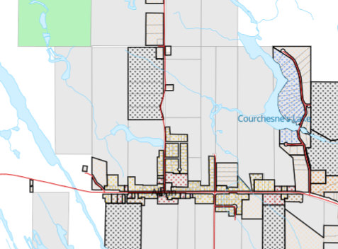

Town Limits shall include any property with frontage on the following roads:

From 347 Delamere Road south to the intersection of Delamere Road and Highway 64 (inclusive)
Highway 64 from 492 Highway 64 to 809 Hwy 64 (inclusive)
Courchesne Road
William Street

NOELVILLE

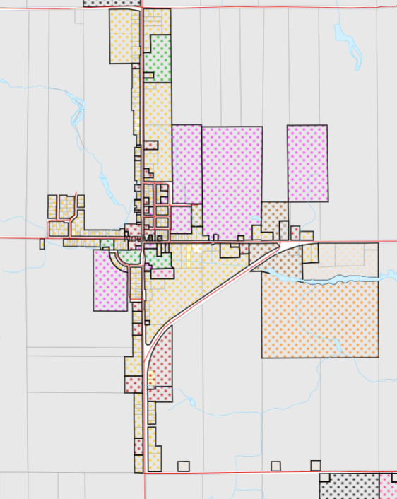

Town Limits shall include any property with frontage on the following roads:
St David Street North
St David Street South
Notre Dame Street East
Notre Dame Street West
St. Antoine Street
St. Christophe Street
Dollard Street
Champlain Street
Vercheres Street
Cartier Street
Edna Street
Daoust Street
Joseph Street
Lahaie Street
Leclaire Street

